(Approx. 490 words)

Kretchmar’s Korner
Windows 10 April 2018 Update
By David Kretchmar, Computer Hardware Technician, Sun City Summerlin Computer Club, NV
June 2018 issue, Gigabyte Gazette
www.scscc.club
t tomburt89134 (at) cox.net.

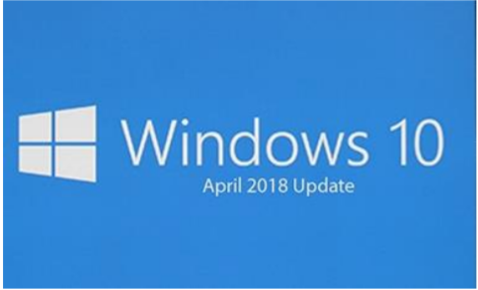
The creative people at Microsoft must have been on break when Microsoft named its newest operating system update a surprisingly uninspired “Windows 10 April 2018 Update”. Windows 10 was first released to the public on July 29, 2015, and the Windows 10 April 2018 Update is the fourth major update to Windows 10. Many of us got Windows 10 as a free update for a Windows prior operating system going as far back as Windows 7. As always, Microsoft has made several security improvements, most of which will be invisible to users. I’m going to talk about some changes that you can utilize.

Timeline
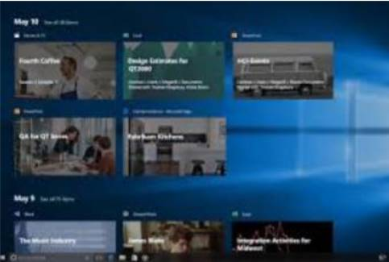
Timeline is the major new feature, and it complements the Task View button that shows what apps are currently running on a system. Timeline lets you see what programs are running, and what apps and activities you’ve used on your Windows 10 PC in the past 30 days. These activities and apps can be set to sync across multiple machines, for example if you’ve been using a laptop for a document you can easily pick up the same activity on a desktop PC that you’re also signed into. If you’re concerned about the privacy aspects of having documents, apps, and activity history in your Task View, Microsoft disables the device sync by default and you can disable activity history.

Dictation
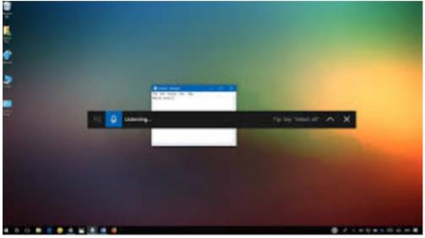
Windows has had other of dictation tools in the past, but Microsoft is creating a quick way to access the built-in Windows 10 version with the April 2018 Update. You can launch it with the windows key + H keyboard shortcut, and it will let you dictate into any app. I dictated part of this article using the dictation tool, and if you’ve got a good microphone (and a quiet room) it works remarkably well.

Microsoft Edge Tab Muting
Chrome has had tab muting for a while, and now Microsoft is bringing the same feature to their Edge browser. You can mute websites in Edge with this feature. Microsoft has stated that they have improved the performance and design of Edge. Microsoft Edge feels a little easier to use now, but it still does not seem as good as Google Chrome, at least to me.

Quick Bluetooth Pairing
Microsoft added quick way to pair Bluetooth accessories, which sometime was a little dicey in older versions of Windows. Windows 10 will now produce a notification to quickly connect to a Bluetooth peripheral and pair it. Microsoft said it is working with Logitech and other vendors to ensure additional hardware will support this quick way to Bluetooth pair.

Windows Defender Notification Reduction
With the Windows 10 April 2018 Update, you can now suppress notifications so you don’t get a popup every time there’s a successful scan.



